MODULE 2 / 3
EXCRETION IN ANIMALS
The process of removal of wastes produced in the cells of the living organisms is called excretion .
Example ;-1) Removal of indigested food
2) Exhalation of carbon di oxide
3 ) Removal of toxic substance
The parts involved in the process of excretion form the excretory system .
EXCRETORY SYSTEM IN HUMAN
The human excretory system consists of
- Kidney
- Ureter
- Urinary bladder
- Urethra
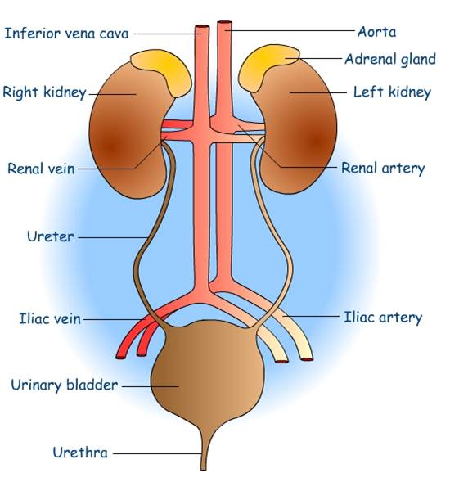
The waste which is present in the blood has to be removed from the body. A mechanism to filter the blood is required . This is done by the blood capillaries in the kidneys. When the blood reaches the two kidneys it contains both useful and harmful substance. The useful substances are absorbed back into the blood .
The wastes dissolved in water are removed as urine. The urine goes into the urinary bladder through tube like ureters. It is stored in the bladder and is passed out through the urinary opening at the end of the muscular tube called uretha.
The kidneys , ureters , urinary bladder and uretha form the excretory system .

COMPOSITION OF URINE

The urine consists of 95% water , 2.5% urea and 2.5% other waste products.

An adult human being normally passes about 1 – 1.8 L of urine in 24 hours.

EXCRETORY PRODUCTS IN DIFFERENT ANIMALS

The way in which waste chemicals are removed from the body of the animal depends on the availability of water .
Aquatic animals ( fish etc.) --Ammonia
Land animals ( birds lizards,snakes etc) --uric acid,
Humans -- urea

DIALYSIS

Sometimes a person’s kidneys may stop working due to infection or injury . As a result of kidney failure , waste products start accumulating in the blood . Such persons cannot survive unless their blood is filtered periodically through an artificial kidney. This process is called dialysis

