Atomic Energy Education Society – Distance Learning Programme
Class – VI Subject – Mathematics
Chapter – 9: DATA HANDLING

Handout – Module 2/3

Other methods of organising the data
Let us observe and understand picture representation of data in order to answer the question on data at a glance
We can answer many questions by just studying the diagram.
Pictures visually help us to understand the data.
This picture representation is a pictograph.
Pictograph
A pictograph represents data through pictures of objects. It helps answer the questions on the data at a glance.
Pictographs are often used by dailies and magazines to attract readers attention
It requires some practice to understand the information given by a pictograph.
Interpretation of pictograph
- A pictograph represents data in the form of pictures, objects or parts of objects.
- We can also interpret a pictograph and answer the related questions.
- Different types of information can be obtained from a pictograph
Drawing a pictograph
Pictographs can be drawn using symbols to represent a certain number of items or things
Sometimes, a symbol may represent multiple units and may be difficult to draw.
Instead of it we can use simpler symbols
Now let us draw and interpret a pictograph-
Students of Class VI in a school were given a task to count the number of articles made of different materials in the school. The information collected by them is represented as follows:
Material used | No. of articles
Wood | 30
Glass | 20
Metal | 50
Rubber | 25
Plastic | 35

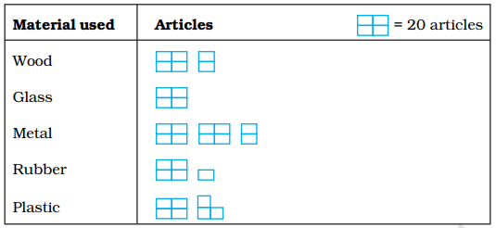
- Which material is used in maximum number of articles?
- Metal
- Which material is used in minimum number of articles?
- Glass
- What is the total number of articles counted by the students?
- 160
^*^*^*^*^*^*^*^*^

