HAND OUT 1 for LESSON 12 Electricity and Circuits

Introduction to Electricity and Circuits

ELECTRICITY IS A SOURCE OF ENERGY
It has become so common that sometimes we forget its immense applications.

Advantages of Electricity:
- Light in our houses, offices, roads etc. even past sunset
- To operate pumps which in turn have a lot of applications
- Electrical appliances like refrigerator, fans etc.
- Building houses, installing equipment etc.
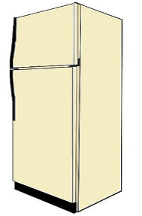
Refrigerator {Electric Appliance}

Electric Cell and Electric Bulb

Features of an Electric Cell:
- It is a small cylindrical structure which helps in operating the devices.
- A small metal cap is placed on one side and a metal disc is present on the other side.
- All cells have two terminals: Positive and Negative.
- The metal cap and metal disc are positive (+) and negative (-) terminals of the electric cell respectively.
- Chemical energy is converted into electrical energy inside a cell. When the chemicals are exhausted, the cell stops working.
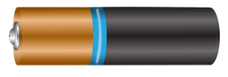
Electric Cell

Features of an Electric Bulb:
- The outer covering is glass and the base is metallic.
- The part of the bulb which glows is called Filament and is made up of tungsten.
- The filament is attached to two wires. One of the wires is connected to the metal case at the base and the other wire is connected to the metal wire at the centre of the base.
- Base of the bulb and metal tip are the terminals of the bulb and they do not touch each other.
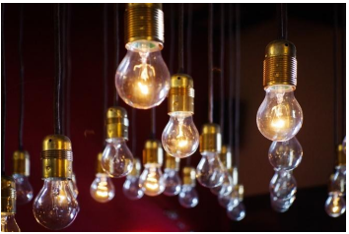

Electric Bulb

Prepared by
VARALAKSHMI. M TGT (SS)
AECS, ANUPURAM

