Visualising Solid Shapes
WORKSHEET:1 Module:1/2
CLASS: VIII SUBJECT: MATHEMATICS

Q.1.Draw the front, side and top views of the following 3-D figures.
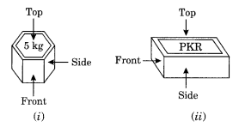

Q.2.Draw any four 2-dimensional figures.

Q.3.Draw any four 3-dimensional figures.

Q4..For each of the given solid, the 3 views are given identify for each solid the corresponding top, front and side views.
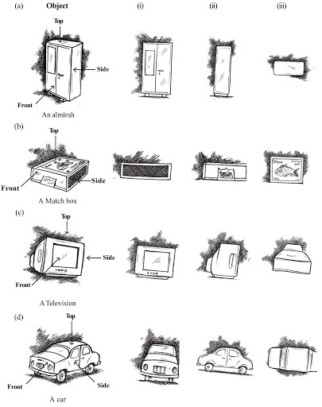
Q.5.Draw the front view, side view and top view of your classroom table.

