1. Write the number of lines of symmetry that each of the figures show.
Atomic Energy Education Society
Class:-6 Sub:Mathematics
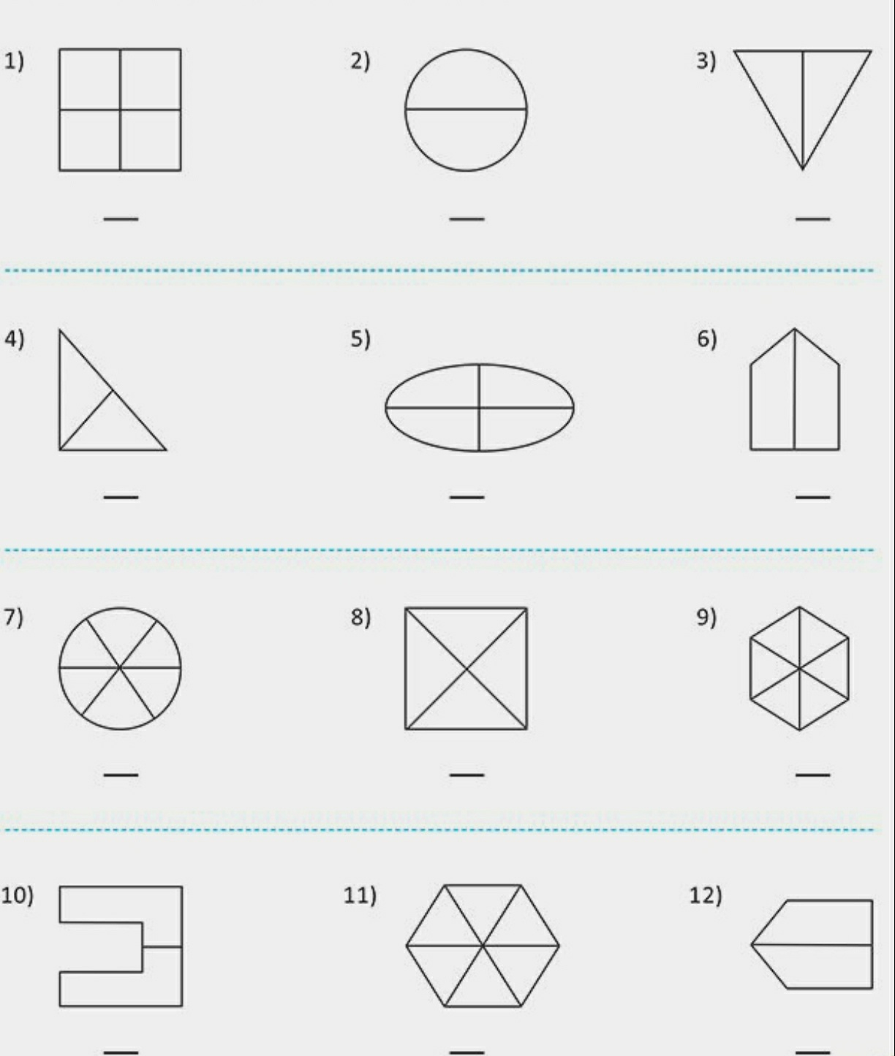
Worksheet- 2
