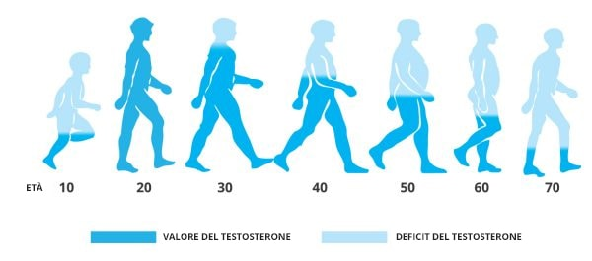
- Population change (Ref. Module- 2/3_Slide 2/9)
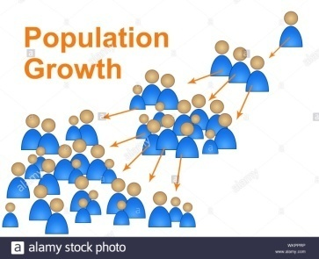

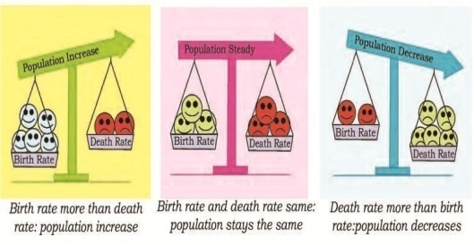
- World Population Growth (Ref. Module- 2/3_Slide 3/9)

- Birth Rate, Death Rate and Migration (Ref. Module- 2/3_Slide 4/9)

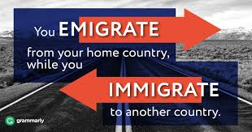
- Migration: Emigration and Immigration (Ref. Module- 2/3_Slide 5/9 and 6/9)
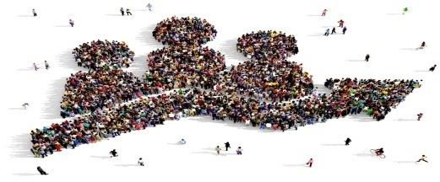
- Patterns of population change(Ref. Module- 2/3_Slide 7/9)

- World Map: Differing rates of population growth (Ref. Module- 2/3_Slide 8/9)

