Atomic Energy Education Society – Distance Learning Programme
Class – VI Subject – Mathematics
Chapter – 9: DATA HANDLING

Handout – Module 1/3

Introduction
We observe different tables in order to gather the information recorded in the table.
In our day to day life, we have seen several kinds of tables consisting of numbers, figures, names etc. These tables provide “DATA”
A data is a collection of numbers gathered to give some information.
Some examples of data are – marks scored by students in a class, number of students in various classes in a school, preferences of foods among the residents of a building. Cricket score analysis, etc.
Recording of data
The data collected should be recorded by various methods.
Group and compare raw data systematically in order to infer the relevant information quickly
Organisation of data
We need to organise the data systematically and efficiently for large number of observations.
One effective method to organise raw data into a table is by using tally marks in order to organize the given data.
So to get a particular information from the given data quickly, the data can be arranged in a tabular form using tally marks.
When the observations are large, it may not be easy to find the number of observations by simply counting, so we make the use of tally marks.
Tally marks are usually marked in bunches of five.
The first four tallies are marked vertically.
The fifth tally in a bunch is marked diagonally across the earlier 4 i.e. 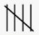
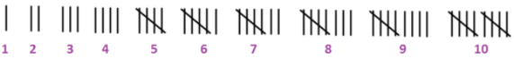

Example:
A teacher asked students about the choice for their favourite past time. She recorded the data as:
Reading, Playing, Drawing, Reading, Playing, Playing, Painting, Drawing, Drawing, Watching, Drawing, Drawing, Playing, Watching, Drawing.
The representation of the information in the table using tally marks is as follows:




